September 2021
P.B.I.S. & Social/Emotional Learning Skill:
Empathy Growth Mindset Mantra – “Everybody Can Learn!”
**Keep up with our school on Social Media for Updates & Announcements:
Facebook: https://www.facebook.com/BlankenburgElementary/
School District Website: https://blankenburg.philasd.org/
Blankenburg Parent Association https://sites.google.com/philasd.org/bpa-blankenburg-community-page/home
CLASS DOJO https://www.classdojo.com/invite/?s=5977dcabab24c9e257e6e73f
Instagram:@RudolphBlankenburgElementary
 | September 2021
Sun | Mon | Tue | Wed | Thu | Fri | Sat
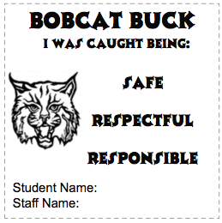  29 | 30 | 31  First Day of School  Welcome Back Scholars | 1  Kindergarten  - 3 Hour Early Dismissal | 2  Kindergarten  - 3 Hour Early Dismissal | 3  Kindergarten  - 3 Hour Early Dismissal | 4  EARN DOJO POINTS EVERYDAY
5  EARN BOBCAT BUCKS EVERYDAY | 6  SCHOOL CLOSED  Labor Day | 7  SCHOOL CLOSED  Rosh Hashanah | 8 World Literacy Day | 9 | 10  SCHOOL WIDE BLANKENBURG TOWN HALL | 11
12  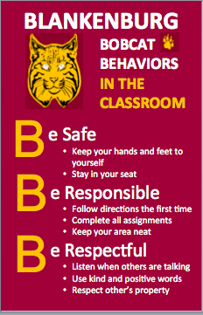 | 13  I-Ready (Reading)  PBIS/SEL Leadership Team  3:30PM - 4:00PM | 14  I-Ready (Mathematics)  World First Aid Day | 15  Back to School Night 3:30PM-5:00PM  Information Session  @ 3:30PM-3:4 pm | 16  SCHOOL CLOSED  YOM KIPPUR | 17 | 18  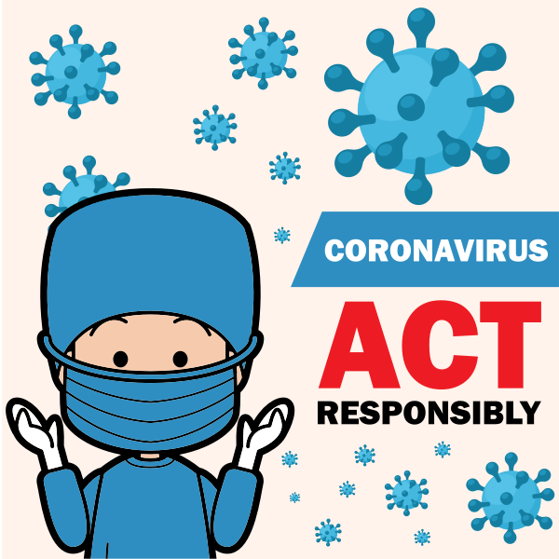
19  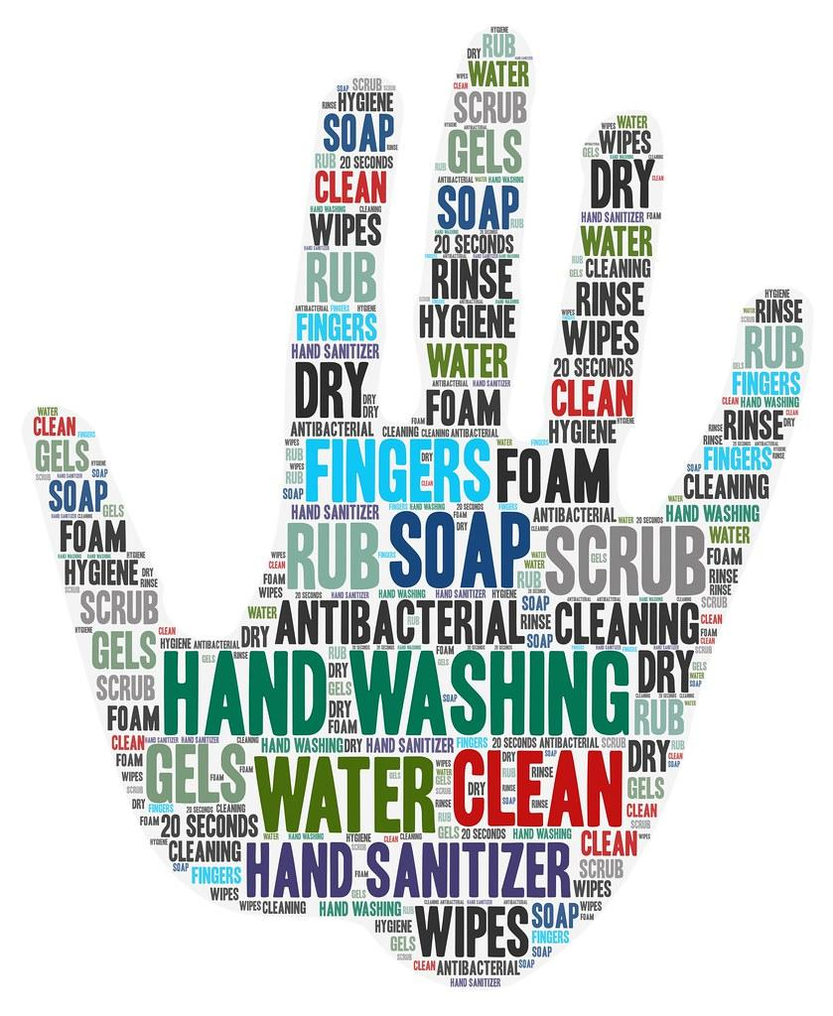 | 2o | 21 | 22 | 23 | 24 | 25
26 | 27 | 28 | 29 | 30 | 1  EARN BOBCAT BUCKS EVERYDAY | 2  EARN DOJO POINTS EVERYDAY
Merit Calendar Key-Scholars can earn up to 2 points a day. 1 point for wearing their uniform and showing positive behavior throughout the day. SCHOLARS THAT EARN 32 POINTS WILL EARN PBIS SEPTEMBER PRIZE!!!!
1a: I actively participated in class today and wore my uniform! | 2a: I was not focusing on/completing class work.
1b: I followed the teacher's directions and wore my uniform! | 2b: I did not complete my homework.
1c: I followed rules in the hallway, lunchroom, playground and with specialists and wore my uniform! | 2c: I was disrespectful to a classmate.
1d: I kept my hands and feet to myself and wore my uniform! | 2d: I misbehaved in the hallway, lunchroom, playground, or with a specialist.
1e: I made an improvement in my behavior and I wore my uniform! | 2e: I was excessively talking during instruction and/or classwork.

